 2018

 **August 6** – Riverside Borough Council Meeting at 7:00 pm

**August 1 - 4** - Montour DeLong Community Fair, Washingtonville 

**Evening Entertainment Schedule – 6 pm and 8 pm**

8/1 – Lucky Afternoon

8/2 – The Less Boys

8/3 – Lucky Afternoon

8/4 – Southern Tyde at 7 pm

**August 4** - 7th Annual Charity Duck Drop – Danville/Riverside Bridge – 11 AM – 1 PM 

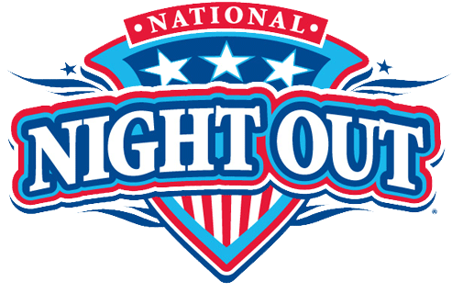

**August 7** - National Night Out – 5 pm – Washies Playground, Danville

**August 8** – Zoning Variance Hearing – 6:30 pm

**August 11** - Pine Street Lutheran Church Ice Cream Festival, 9 am-2 pm

Yard Sale, 8 am – noon, [www.pinestreetlutheran.org](http://www.pinestreetlutheran.org)

**August 16** - Ice Cream Social, St Peter’s UM Church - 4 pm; Danville Band 

 **August 25** - Wine and Brew Fest, Southside Fire Company, 1 - 5 pm

**August 23** – Danville Schools Open – First Student Day

**Rebecca Steckley, Tax Collector**, will have office hours in the Municipal Building, 415 Dewart Street, on Tuesdays & Thursdays, from 4:30 pm-6:00 pm

**CONCERT IN THE PARK** - Memorial Park, Bloom Road, Danville at 7:00 pm

August 7 – Seasoned Sounds – Big Band Swing Era Sounds – FINAL CONCERT